Mum would give Jack some tea
I have recently received a cutting from the Guardian from a friend with the article about Paper Jack. I grew up in Wallington and remember him well. He was a well known character in Wallington in the 1920s and 1930s. Paper Jack would knock on our door and ask mum to make him a jug of tea. He provided his own tea in a screw of paper. My mother would give him a cake to have with his tea. Here is a picture of me and my two brothers with Paper Jack as he drank his tea. I am the oldest boy in the picture. Paper Jack is sitting on the bank opposite our house in Plough Lane.
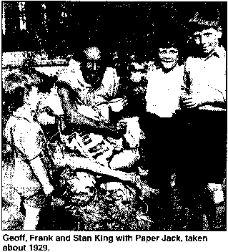
The houses in the lane are part of the high view estate which had just been built in 1929. Croydon Aerdrome was at the end of the road. My father had recently retired from Croydon Police after 25 years.
Submitted by Goeff King, Crowsley Way, Sonning Common, Reading
Addiscombe Heritage - Published Articles

Memories Of Everyone's Favourite Hobo Paper Jack
"At first he wore an old tail coat with trousers of a sort and a very old battered top hat. Gradually this was replaced with an assortment of paper until he became fully clothed in paper. He always left his arms bare, even in winter, and he made footwear from an old car inner tube. This made a very strange noise in the black out, but no one had any fear of him and treated him like a friend, especially the children who loved him and gathered in groups to listen to the story telling.
"He was cultured, gentle and well mannered, with a Christ like appearance in a rough sort of way. He never begged, but local people welcomed him with a jug of tea. I can see him now, sitting in the drive of an old derelict mansion house opposite a family home eating his bread and cheese, which he bought in the village shop. He was never feared and I dread to think what would happen to him in today's world.

"News of his tragic death brought great sadness to all who knew him. There will never be another Paper Jack. We all felt we had lost a friend. My brother was a prisoner of war at the time of Paper Jack's death and my mother posted photos to Germany, which he has to this day."
Mrs E Jones from Berwyn, America, writes: "As a child I lived in The Lodge, Church Road, Beddington. Paper Jack would on occasions be sitting under a tree outside The Lodge (he never came to the door). My mother would take out a jug of tea and some food. He spoke in a soft cultured voice. He was also a visitor to friends of ours who lived in a cottage behind The Plough Inn, their name was Davies.
"I wonder if that cottage is still there? I doubt it. I remember passing Paper Jack at dusk near Guy Road, but never felt afraid at that time. I was probably going to or from music lessons in Bridge Lane.
"Although my memories of Paper Jack are few, your article brought back so many memories and I thank you for those. In 1940 we moved to Cheam Village, West Drive, where I married and thereby hangs another tale.
River Wandle and Waddon Mill: According to readers' memories, the itinerant Jack lived in Wandle Park after his marriage broke down and he moved out of the family home in Biggin Hill.
Picture from Edwardian Croydon Illustrated, Croydon Natural History And Scientific Society (1990)
This Is Hertfordshire

